**Accessing Prodigy**

If you do not remember your sign in and password, please email your teacher.

**(Guardian) Please register to support your child’s learning:**

1. Go to prodigygame.com/welcome

2. Sign up (it’s free!) and link your parent account using your child’s credentials

**Student Accounts:**

1. Go to prodigygame.com

2. Select **‘Play Prodigy’** in the top-right corner



3. Once the game loads, enter your child’s username and password and select ‘LOGIN’

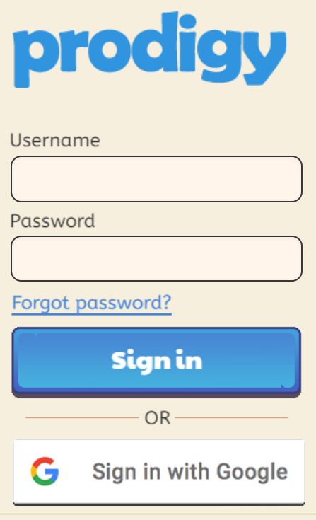

**Student Daily Checklist**

1. Check **Canvas** daily for Announcements & Calendar
2. Check **Khan Academy** for ASSIGNED Assignments/ Lessons
3. Check **Prodigy** for ASSIGNED work
4. **Email teacher** if you have any questions:

[stracy@everettsd.org](mailto:stracy@everettsd.org) – Mrs. Tracy

**Khan Academy Class Codes**

|  |  |
| --- | --- |
| Period 1 | H54MR8WQ |
| Period 2 | FRKV93Y2 |
| Period 3 | 56ZMX9JV |
| Period 5 | NXMXRSAH |
| Period 6 | FNCD6B7D |
| Period 7 | UQA49V8T |

**Follow Steps to Sign into Khan Academy Account:**

1. **Type in** [www.khanacademy.com](http://www.khanacademy.com)



1. Click **“Login”** in top right corner
2. 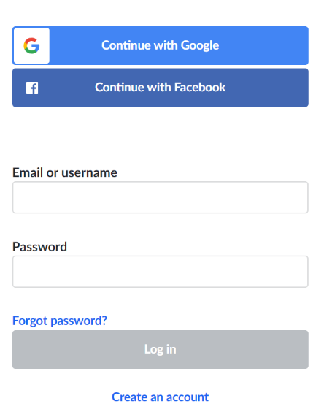Click **“Continue with**

**Google”**

1. **Username:** Student ID# @apps.everettsd.org

**Password:** (Regular School Password)

6. Once you have joined, you can now sign in at home and complete the “Assignments” (Located on the left side of page.)

**Accessing Canvas:**

1. Type in <https://www.everettsd.org/domain/2152>
2. Click on

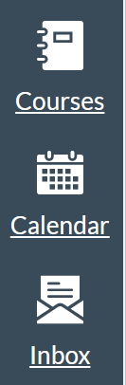

* Click on ‘Courses’ 🡪 Select your Math Class Period.
* Check **Calendar** for Assignments
* You can also contact me by emailing me through Canvas. **Check email daily** for any important information.

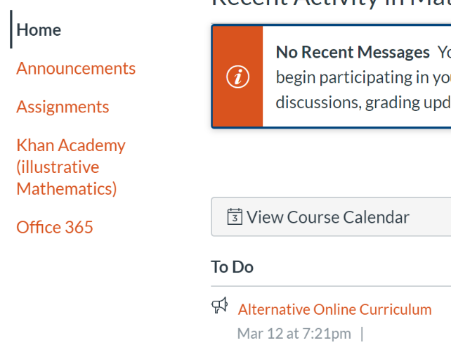

3. Check **Announcements and Assignments** daily.